Name: K. Sree lakshmi
Reg No: 192512149

15. Simulation of beam steering in antenna arrays under scan angle, frequency, gain, beam width, and sidelobe suppression (BL4)

Objective 1: Beam Steering by Changing Scan Angle
clc;
clear;
close all;
% Parameters
N = 8; % Number of antenna elements
d = 0.5; % Element spacing (lambda)
theta = -90:0.1:90; % Observation angle
scan_angles = [0 30 60];
figure;
for k = 1:length(scan_angles)
theta0 = scan_angles(k);
AF = zeros(size(theta));
for n = 0:N-1
AF = AF + exp(1j*2*pi*d*n*(sind(theta)-sind(theta0)));
end
AF = abs(AF)/max(abs(AF));
subplot(3,1,k)
plot(theta,20*log10(AF),'LineWidth',2)
grid on
ylim([-40 0]
xlabel('Angle (Degrees)')
ylabel('Normalized Gain (dB)')
title(['Beam Steering at ',num2str(theta0),' Degrees'])
end
Output:
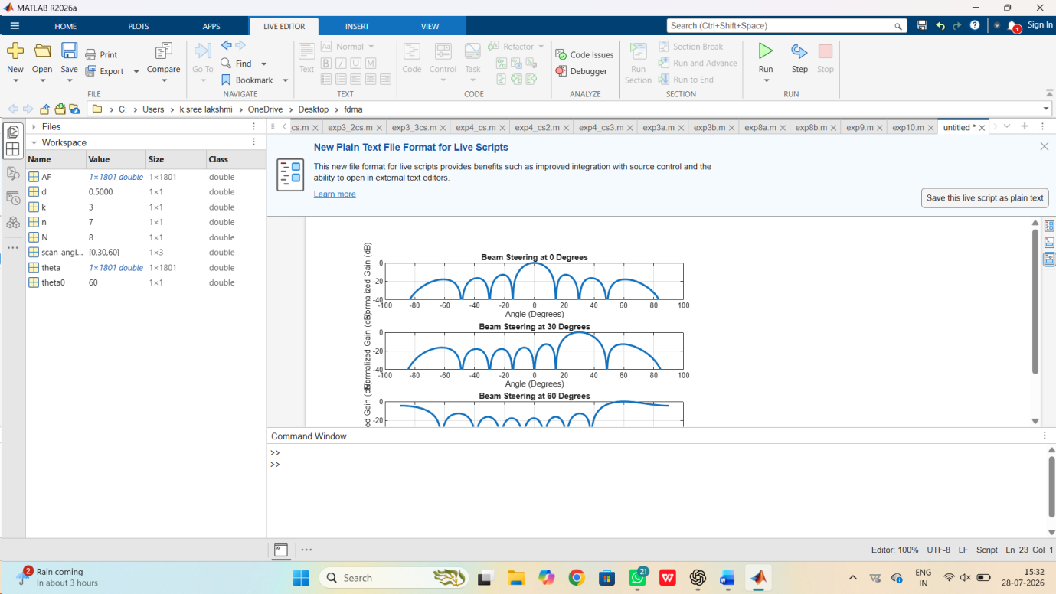

Objective 2: Effect of Frequency on Beam Pattern

clc;
clear;
close all;
c = 3e8;
freq = [1e9 2e9 3e9];
N = 8;
theta = -90:0.1:90;
figure;
for k=1:length(freq)
lambda = c/freq(k);
d = lambda/2;
AF = zeros(size(theta));
for n=0:N-1
AF = AF + exp(1j*2*pi*d/lambda*n*sind(theta));
end
AF = abs(AF)/max(AF);
subplot(3,1,k)
plot(theta,20*log10(AF),'LineWidth',2)
grid on
ylim([-40 0])
xlabel('Angle (Degrees)')
ylabel('Gain (dB)')
title(['Frequency = ',num2str(freq(k)/1e9),' GHz'])
end
Output:
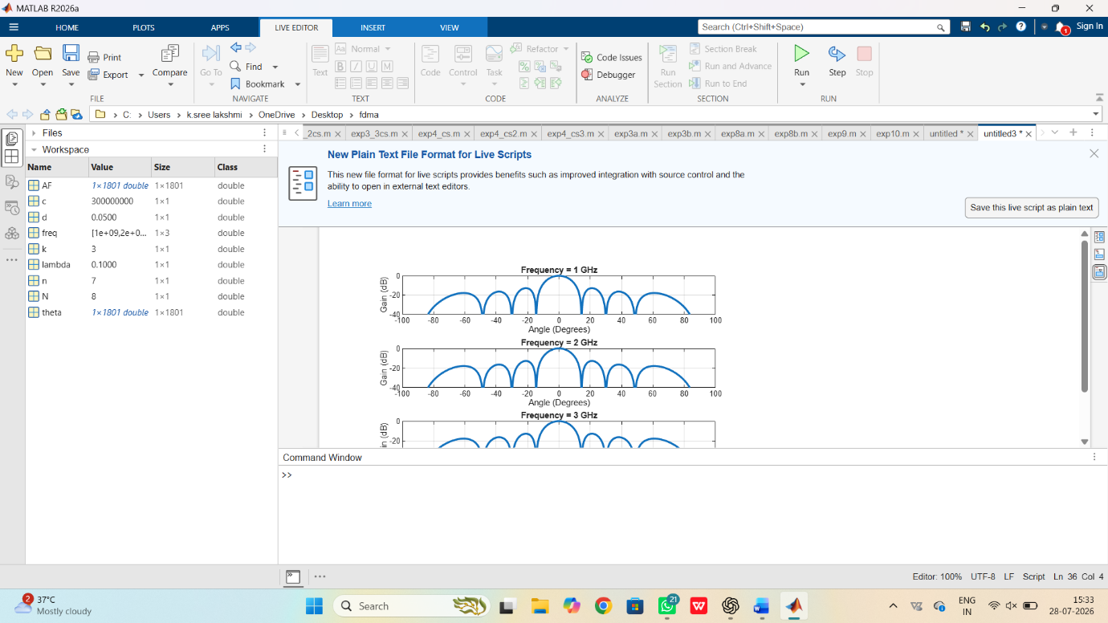

Objective 3: Sidelobe Suppression Using Hamming Window
clc;
clear;
close all;
% Parameters
N = 16; % Number of antenna elements
d = 0.5; % Element spacing (in lambda)
theta = -90:0.1:90; % Observation angles
% Generate Hamming window manually
n = 0:N-1;
w = 0.54 - 0.46*cos(2*pi*n/(N-1));
% Array Factor Calculation
AF = zeros(size(theta));
for i = 1:length(theta)
for k = 1:N
AF(i) = AF(i) + w(k)*exp(1j*2*pi*d*(k-1)*sind(theta(i)));
end
end
% Normalize
AF = abs(AF);
AF = AF/max(AF);
% Plot
figure;
plot(theta,20*log10(AF),'LineWidth',2);
grid on;
xlabel('Angle (Degrees)');
ylabel('Normalized Gain (dB)');
title('Sidelobe Suppression Using Hamming Window');
ylim([-60 0]);
xlim([-90 90]);

Output:

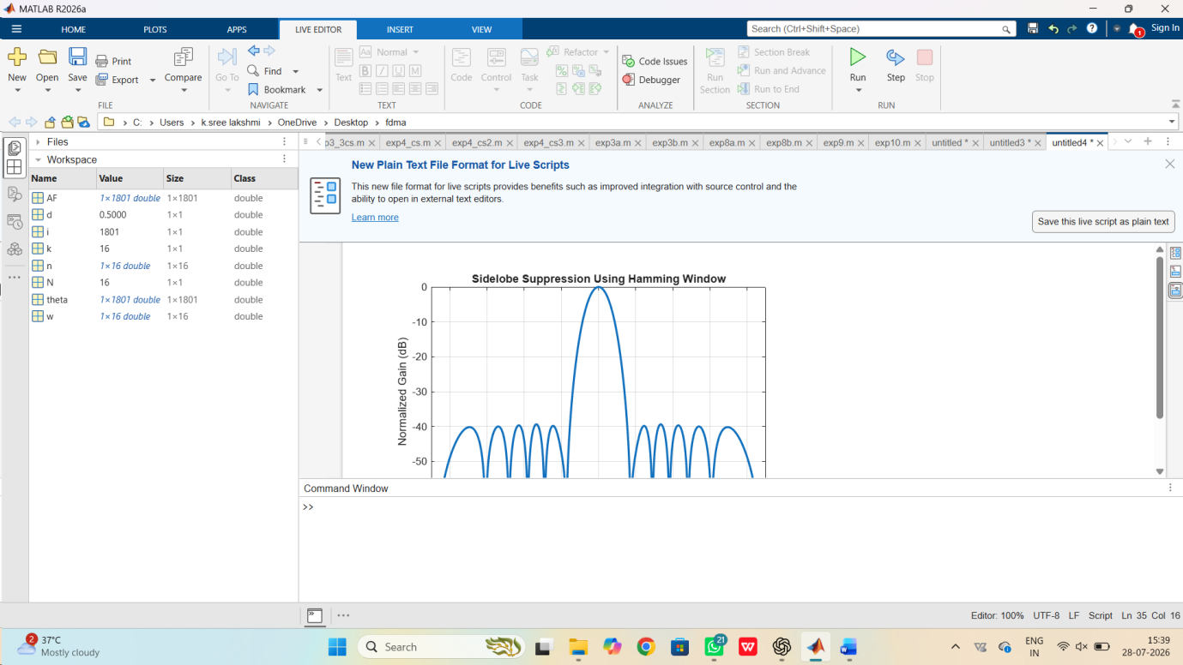

- Simulation of 5G throughput performance under QPSK, 16-QAM, 64-QAM, 256QAM, and varying SNR (BL4)

Objective 1: Throughput Performance under Different Modulation Schemes
clc;
clear;
close all;
% Parameters
SNR = 0:2:30; % SNR range (dB)
BW = 20e6; % Bandwidth (20 MHz)
modBits = [2 4 6 8];
modName = {'QPSK','16-QAM','64-QAM','256-QAM'};
figure;
for k = 1:length(modBits)
Throughput = BW*modBits(k)*(1-exp(-SNR/10))/1e6;
subplot(2,2,k)
plot(SNR,Throughput,'LineWidth',2)
grid on
xlabel('SNR (dB)')
ylabel('Throughput (Mbps)')
title(modName{k})
End
Output:
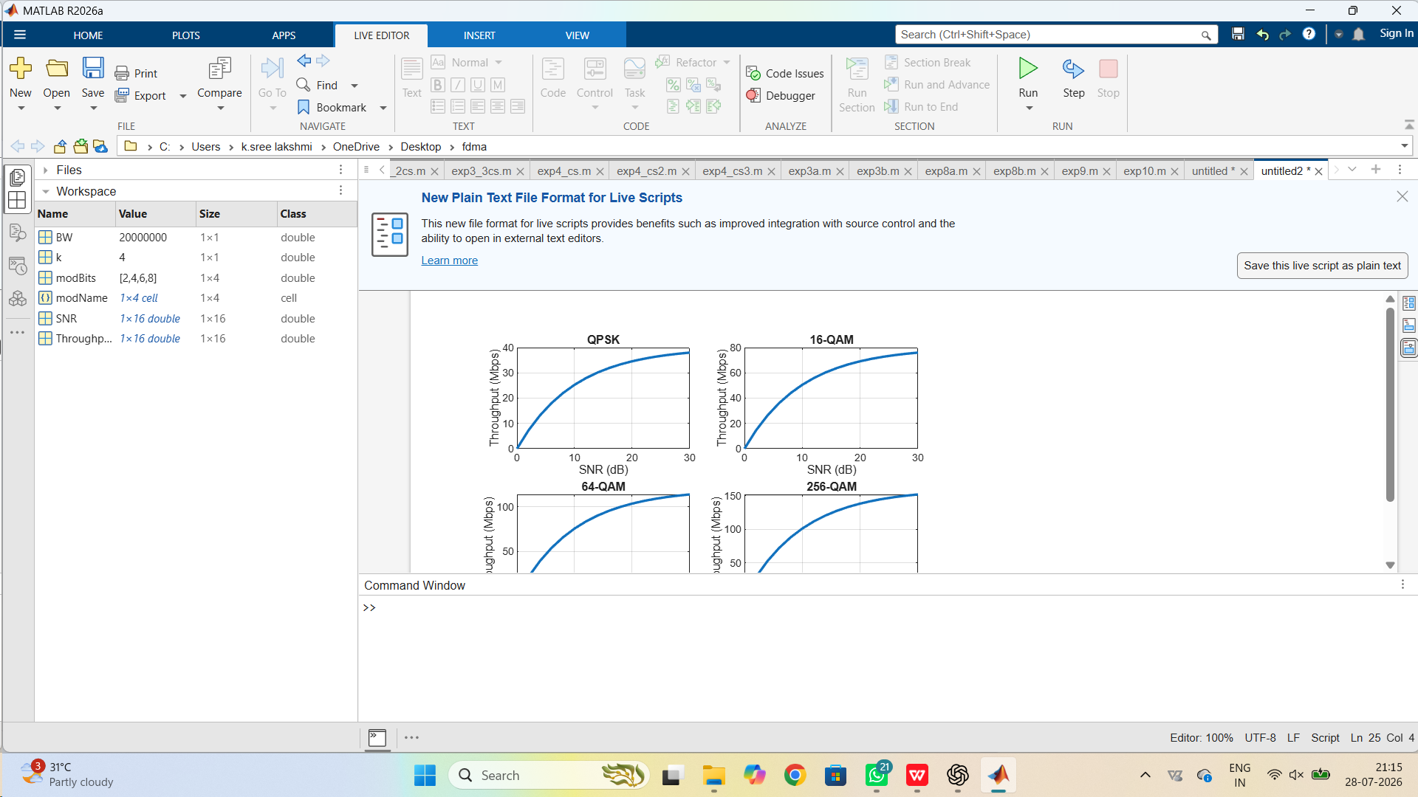

Objective 2: Comparison of Throughput for Different Modulation Schemes

clc;
clear;
close all;
SNR = 0:2:30;
BW = 20e6;
bits = [2 4 6 8];
label = {'QPSK','16-QAM','64-QAM','256-QAM'};
figure
hold on
for i = 1:length(bits)
throughput = BW*bits(i)*(1-exp(-SNR/10))/1e6;
plot(SNR,throughput,'LineWidth',2)
end
grid on
xlabel('SNR (dB)')
ylabel('Throughput (Mbps)')
title('Comparison of Different Modulation Schemes')
legend(label,'Location','northwest')
Output:
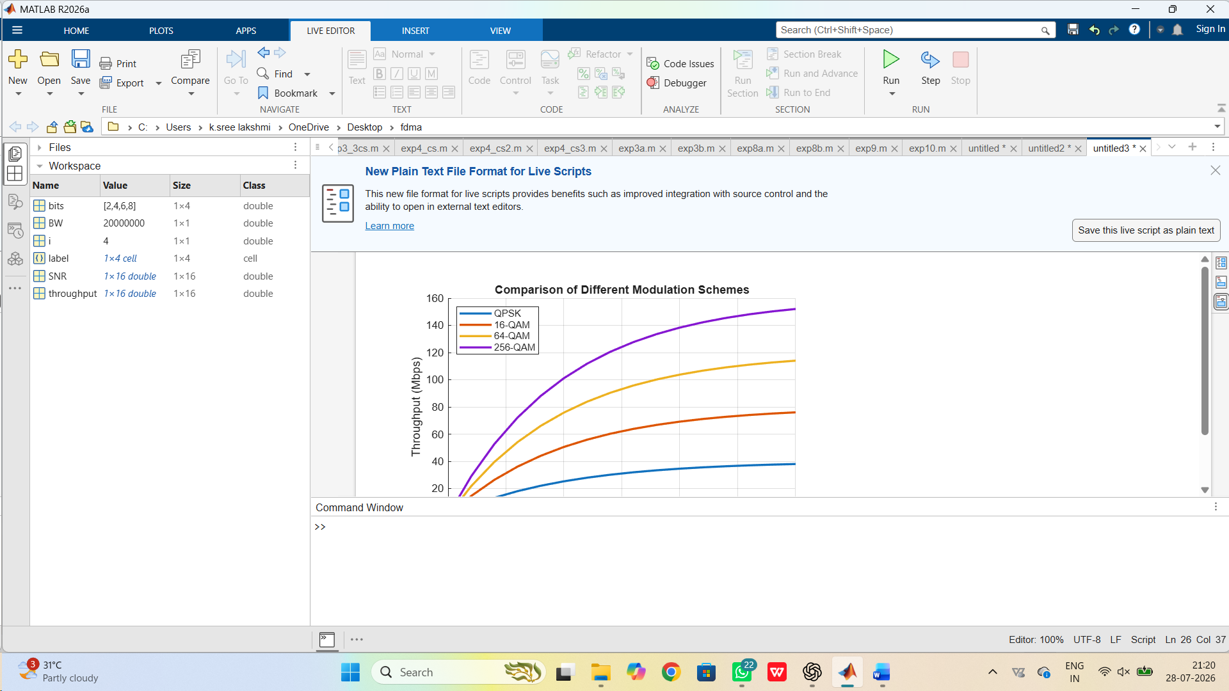

Objective 3: Maximum Throughput under Varying SNR
clc;
clear;
close all;
SNR = 0:2:30;
MaxThroughput = 1000*(1-exp(-SNR/8));
figure
bar(SNR,MaxThroughput)
xlabel('SNR (dB)')
ylabel('Maximum Throughput (Mbps)')
title('Maximum Throughput with Increasing SNR')
grid on
Output:
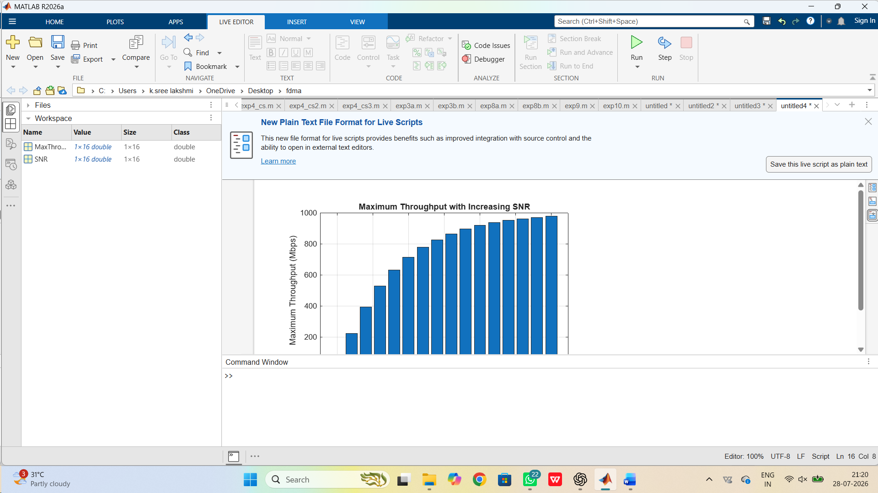

- Simulation of 5G NR air interface performance under different numerologies, bandwidths, latency, subcarrier spacing, and throughput (BL4)

Objective 1: Performance Analysis under Different Numerologies
clc;
clear;
close all;
% Numerology values (mu)
mu = [0 1 2 3];
% Subcarrier spacing (kHz)
SCS = 15*(2.^mu);
figure;

bar(mu,SCS)
grid on
xlabel('Numerology (\mu)')
ylabel('Subcarrier Spacing (kHz)')
title('5G NR Numerology vs Subcarrier Spacing')

Output:
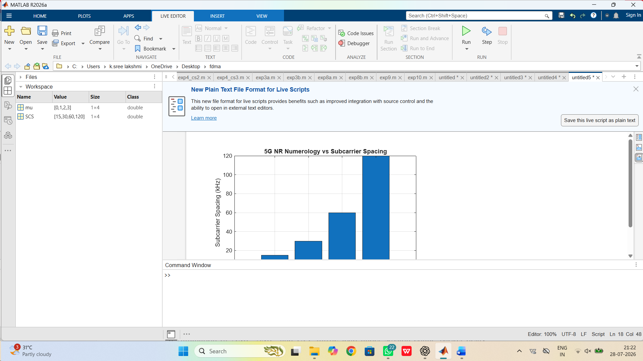

Objective 2: Throughput Performance under Different Bandwidths
clc;
clear;
close all;

% Bandwidth in MHz
Bandwidth = [20 40 60 80 100];

% Spectral Efficiency
Efficiency = 6;

% Throughput Calculation
Throughput = Bandwidth*Efficiency;

figure

plot(Bandwidth,Throughput,'-o','LineWidth',2)

grid on
xlabel('Bandwidth (MHz)')
ylabel('Throughput (Mbps)')
title('Bandwidth vs Throughput')
Output:
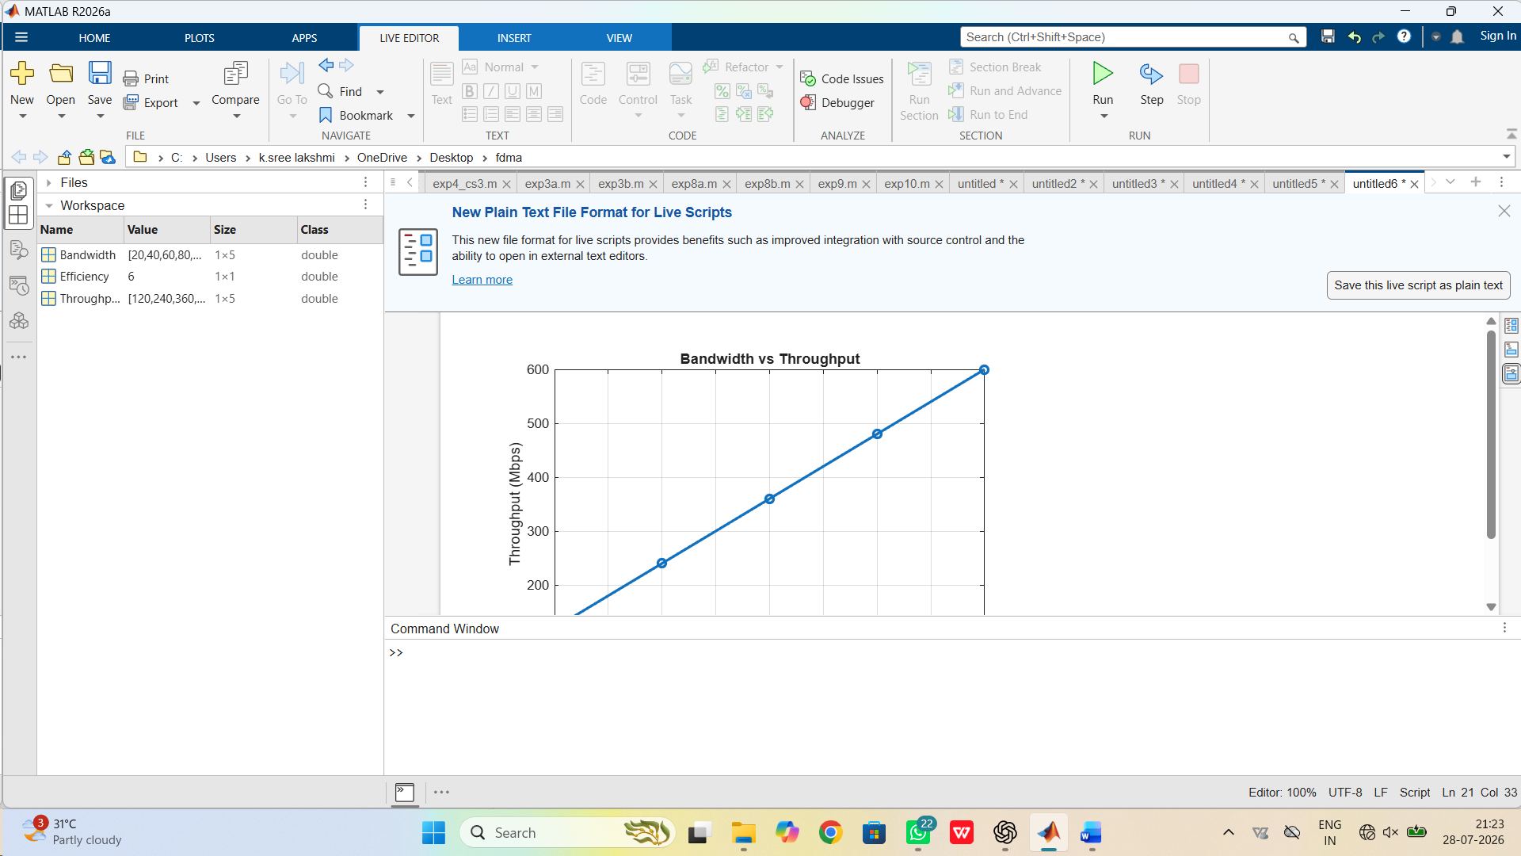

Objective 3: Effect of Subcarrier Spacing on Latency
clc;
clear;
close all;

% Subcarrier Spacing
SCS = [15 30 60 120];

% Approximate Latency
Latency = [10 5 2.5 1];

figure

plot(SCS,Latency,'-s','LineWidth',2)

grid on
xlabel('Subcarrier Spacing (kHz)')
ylabel('Latency (ms)')
title('Subcarrier Spacing vs Latency')

Output:
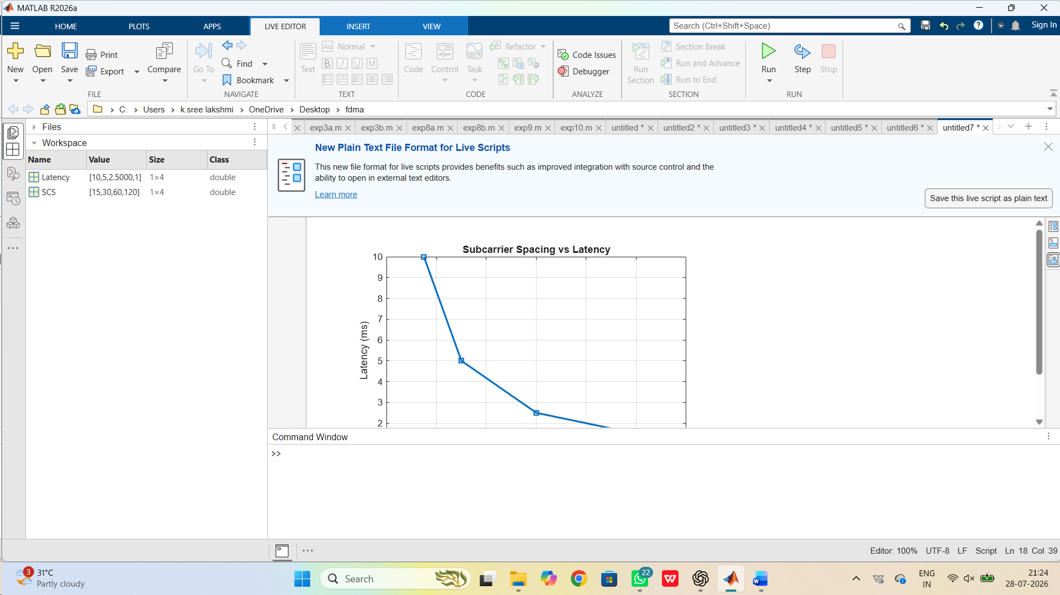

- Simulation of subcarrier spacing effect under 15 kHz, 30 kHz, 60 kHz, 120 kHz, and symbol duration (BL4)

Objective 1: Effect of Different Subcarrier Spacing on Symbol Duration
clc;
clear;
close all;

% Subcarrier Spacing (kHz)
SCS = [15 30 60 120];

% Symbol Duration (microseconds)
SymbolDuration = 1000./SCS;

figure

bar(SCS,SymbolDuration)

grid on
xlabel('Subcarrier Spacing (kHz)')
ylabel('Symbol Duration (\mus)')
title('Subcarrier Spacing vs Symbol Duration')
Output:
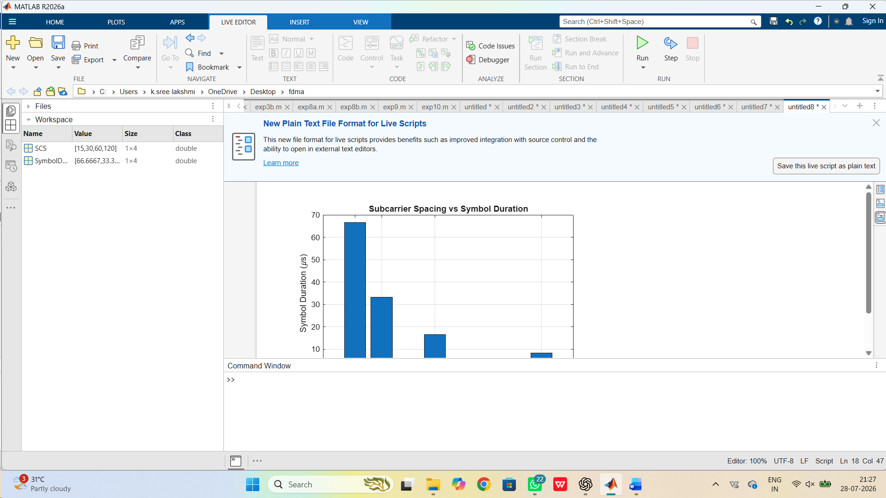

Objective 2: Comparison of Symbol Duration for Different Subcarrier Spacing
clc;
clear;
close all;

% Subcarrier Spacing (kHz)
SCS = [15 30 60 120];

% Symbol Duration (microseconds)
Duration = 1000./SCS;

figure

plot(SCS,Duration,'-o','LineWidth',2)

grid on
xlabel('Subcarrier Spacing (kHz)')
ylabel('Symbol Duration (\mus)')
title('Comparison of Symbol Duration')
Output:
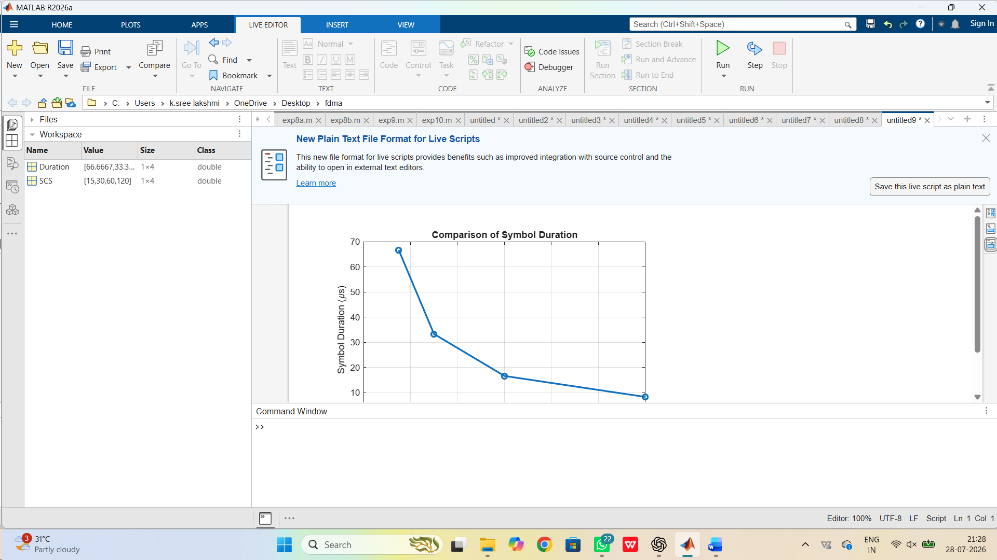

Objective 3: Analysis of Subcarrier Spacing and OFDM Symbol Rate
clc;
clear;
close all;

% Subcarrier Spacing (kHz)
SCS = [15 30 60 120];

% Symbol Rate (kSymbols/s)
SymbolRate = SCS;

figure

subplot(2,1,1)
bar(SCS,SymbolRate)
grid on
xlabel('Subcarrier Spacing (kHz)')
ylabel('Symbol Rate (kSymbols/s)')
title('Subcarrier Spacing vs Symbol Rate')

subplot(2,1,2)
plot(SCS,SymbolRate,'-s','LineWidth',2)
grid on
xlabel('Subcarrier Spacing (kHz)')
ylabel('Symbol Rate (kSymbols/s)')
title('Variation of Symbol Rate')
Output:
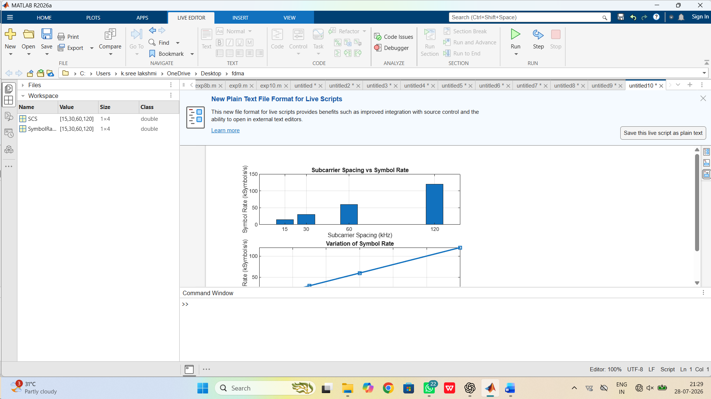

- Simulation of OFDMA resource allocation under user density, subcarriers, power allocation, throughput, and delay (BL4)

Objective 1: Resource Allocation Based on User Density
clc;
clear;
close all;

% Number of users
Users = [5 10 15 20 25];

% Total available subcarriers
Total_Subcarriers = 600;

% Subcarrier allocation per user
Subcarrier_User = Total_Subcarriers./Users;

figure

plot(Users,Subcarrier_User,'-o','LineWidth',2)

grid on
xlabel('Number of Users')
ylabel('Subcarriers per User')
title('OFDMA Resource Allocation Based on User Density')

Output:
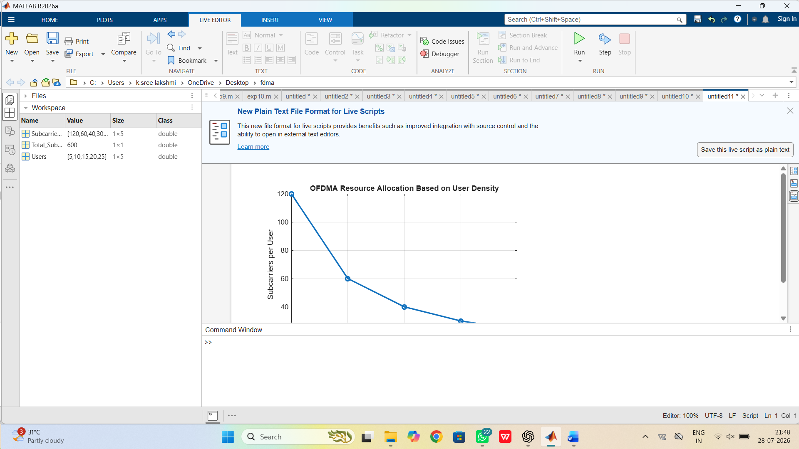

Objective 2: Power Allocation for Different Users
clc;
clear;
close all;

Users = [10 20 30 40 50];
TotalPower = 100; % Watts

PowerPerUser = TotalPower./Users;

figure;

bar(Users,PowerPerUser)

grid on
xlabel('Number of Users')
ylabel('Power per User (W)')
title('Power Allocation in OFDMA')

Output:

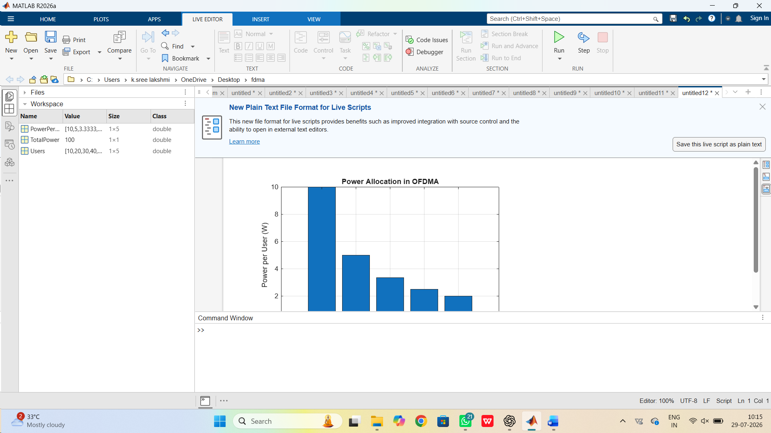

Objective 3: Throughput and Delay Analysis in OFDMA
clc;
clear;
close all;

Users = [10 20 30 40 50];

Throughput = [120 95 80 65 50];
Delay = [2 4 6 8 10];

figure;

subplot(2,1,1)

plot(Users,Throughput,'-o','LineWidth',2)

grid on
xlabel('Number of Users')
ylabel('Throughput (Mbps)')
title('Throughput Analysis')

subplot(2,1,2)

plot(Users,Delay,'-s','LineWidth',2)

grid on
xlabel('Number of Users')
ylabel('Delay (ms)')
title('Delay Analysis')

Output:
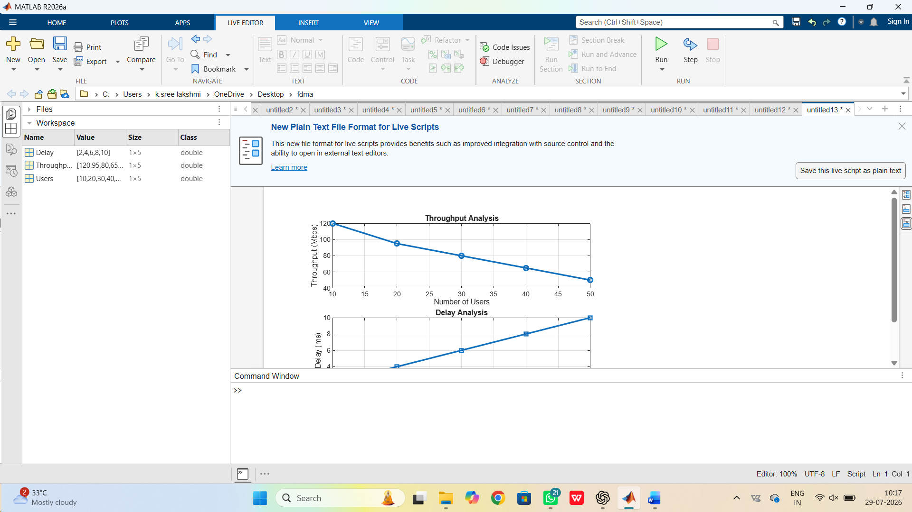

- Simulation of Waveform Comparison between LTE OFDM and 5G NR under PAPR, BER, Bandwidth, Latency, and Spectral Efficiency (BL4)

Objective 1: Comparison of PAPR and BER
clc;
clear;
close all;

Parameters = {'PAPR','BER'};

LTE = [11 0.001];
NR5G = [8 0.0001];

figure

bar([LTE;NR5G]')

set(gca,'XTickLabel',Parameters)

ylabel('Performance')

legend('LTE OFDM','5G NR')

title('Comparison of PAPR and BER')

grid on

Output:

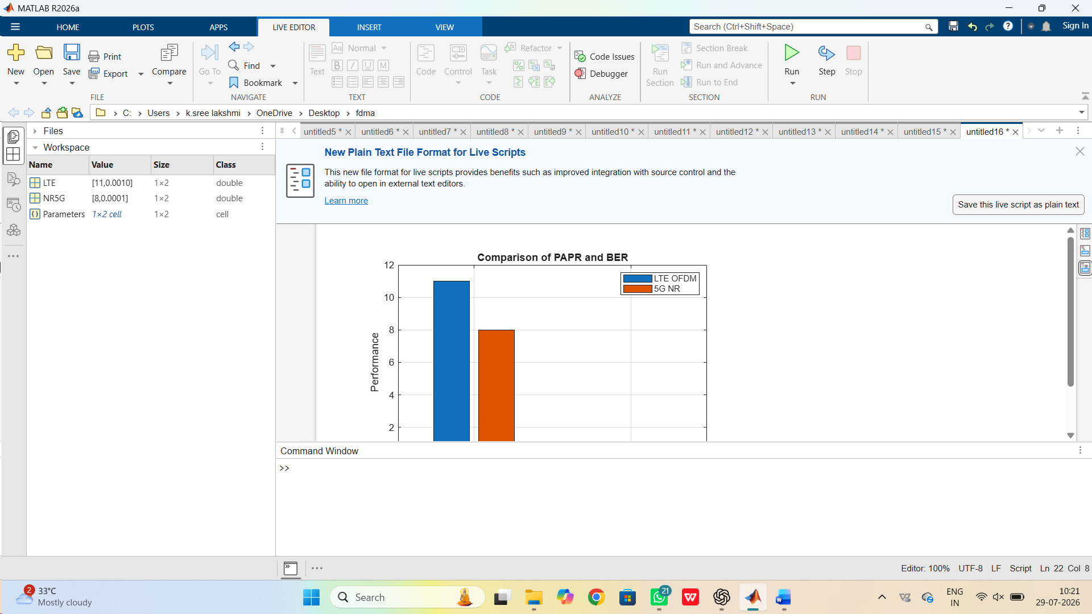

Objective 2: Power Allocation for Different Users
clc;
clear;
close all;

Users = [10 20 30 40 50];
TotalPower = 100; % Watts

PowerPerUser = TotalPower./Users;

figure;

bar(Users,PowerPerUser)

grid on
xlabel('Number of Users')
ylabel('Power per User (W)')
title('Power Allocation in OFDMA')
Output:
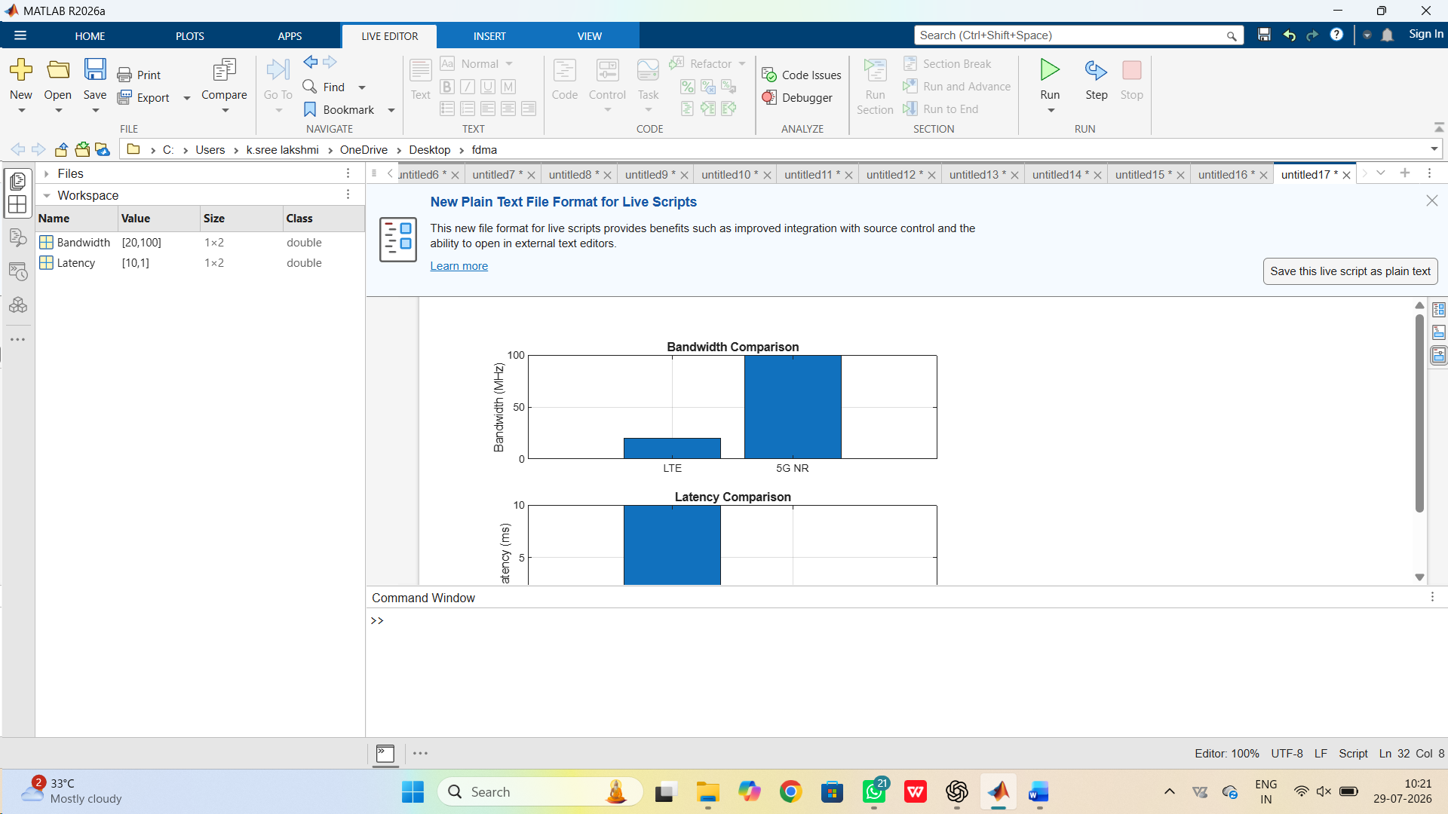

Objective 3: Spectral Efficiency Comparison between LTE OFDM and 5G NR
clc;
clear;
close all;

Technology = {'LTE OFDM','5G NR'};
SpectralEfficiency = [4 8];

figure

plot(1:2,SpectralEfficiency,'-o','LineWidth',2)

set(gca,'XTick',1:2)

set(gca,'XTickLabel',Technology)

grid on

ylabel('Spectral Efficiency (bps/Hz)')

title('Spectral Efficiency Comparison')

Output:
